

Main Insuator copy1
Report date
Jul 5, 2026, 2:58:51 AM
Contents
1. Global Definitions
1.1. Parameters
2. Component 1
2.1. Definitions
2.2. Geometry 1
2.3. Materials
2.4. Electrostatics
2.5. Mesh 1
3. Study 1
3.1. Parametric Sweep
3.2. Stationary
4. Results
4.1. Datasets
4.2. Tables
4.3. Plot Groups

Global Definitions
Date | Jun 29, 2026, 6:28:09 AM

Global settings
Name | Main Insuator copy1.mph
Path | D:\COMSOL\Main_Insuator_copy1.mph
Version | COMSOL Multiphysics 6.3 (Build: 290)

Used products
COMSOL Multiphysics

Computer information
CPU | Intel64 Family 6 Model 186 Stepping 2, 6 cores, 15.66 GB RAM
Operating system | Windows 11

Parameters
Parameters 1
Name | Expression | Value | Description
L0 | 3350.7[mm] | 3.3507 m | total length of insulator
L | 3400[mm] | 3.4 m

Component 1

Definitions

Coordinate Systems

Boundary System 1
Coordinate system type | Boundary system
Tag | sys1

Coordinate names
First | Second | Third
t1 | n | to

Geometry 1
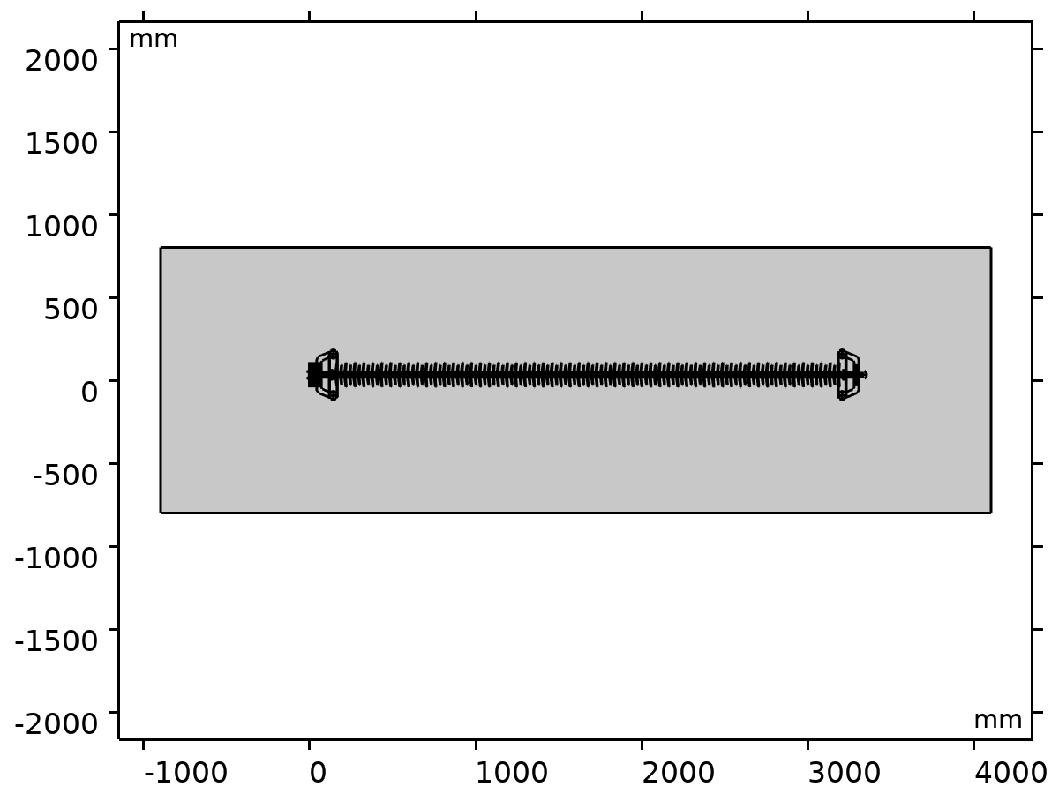
Geometry 1
Units
Length unit | mm
Angular unit | deg

Materials

Air
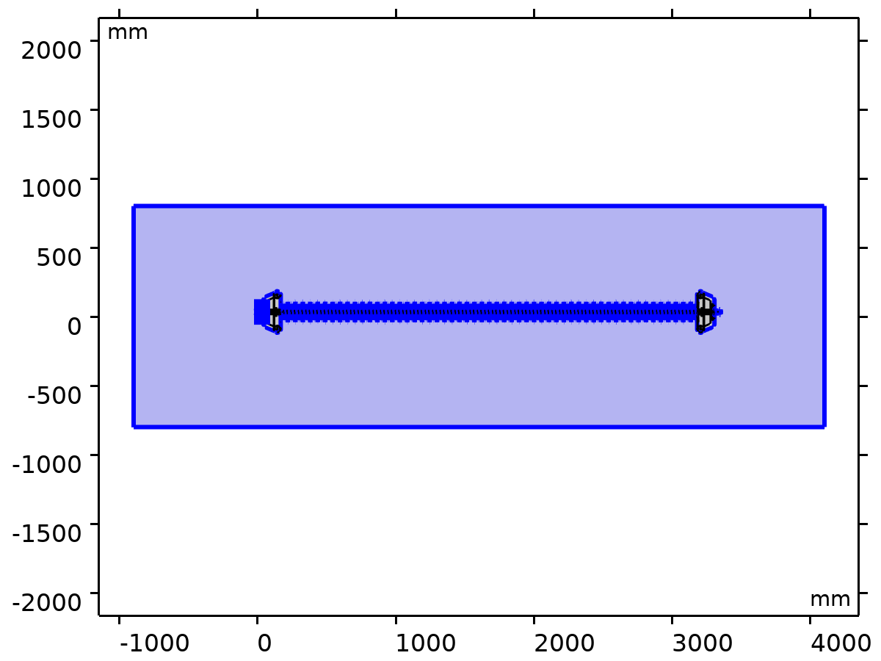
Air
Selection
Geometric entity level | Domain
Selection | Geometry geom1: Dimension 2: All domains

FR4 (Circuit Board)
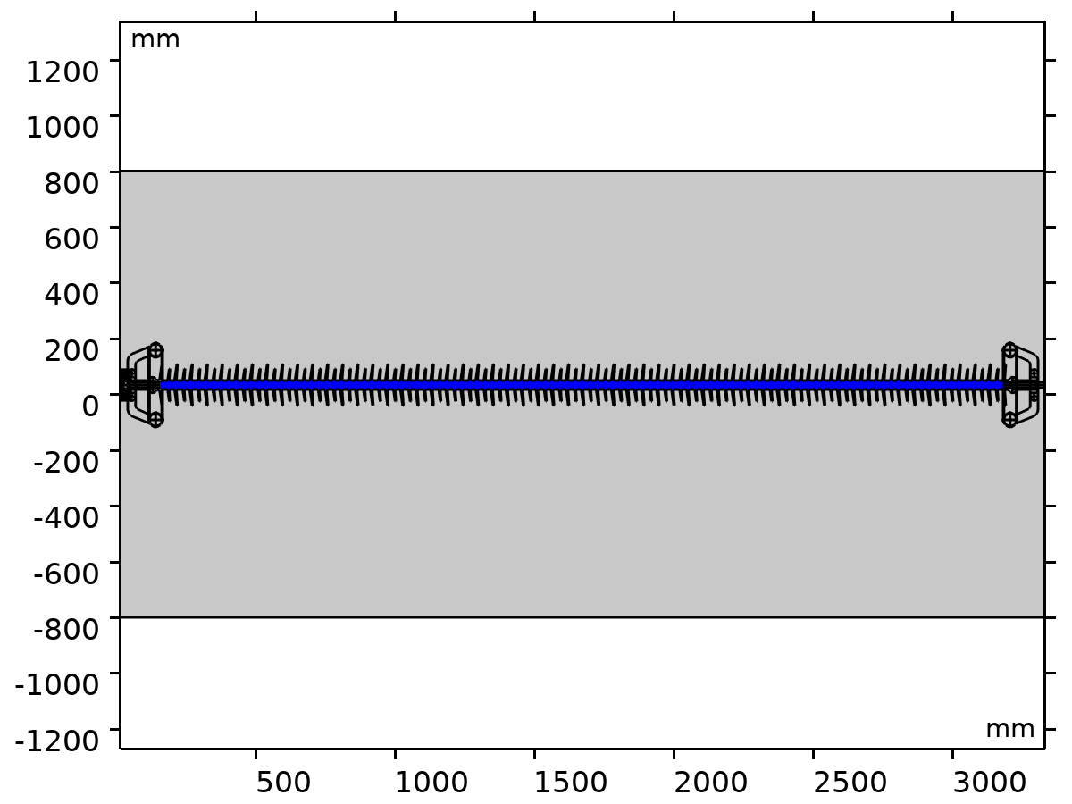
FR4 (Circuit Board)
Selection
Geometric entity level | Domain
Selection | Geometry geom1: Dimension 2: Domains 111–112

Silicon
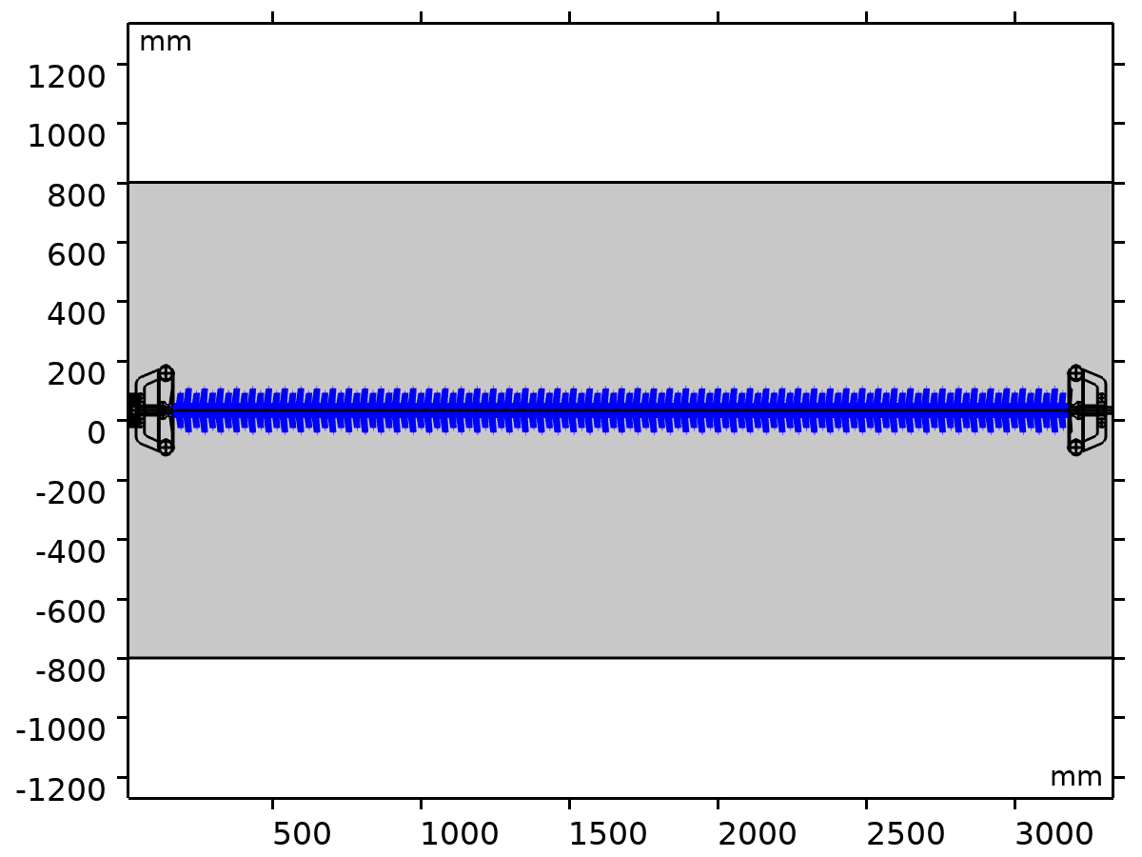
Silicon
Selection
Geometric entity level | Domain
Selection | Geometry geom1: Dimension 2: Domains 110, 113

Aluminum
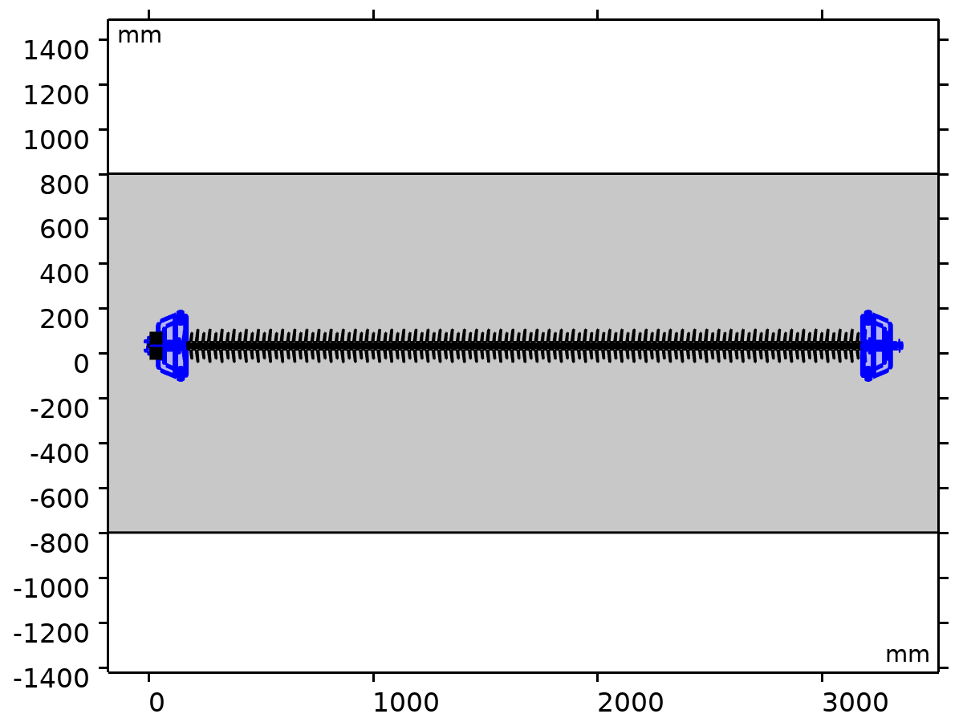
Aluminum
Selection
Geometric entity level | Domain
Selection | Geometry geom1: Dimension 2: Domains 2–109, 114–208

Electrostatics
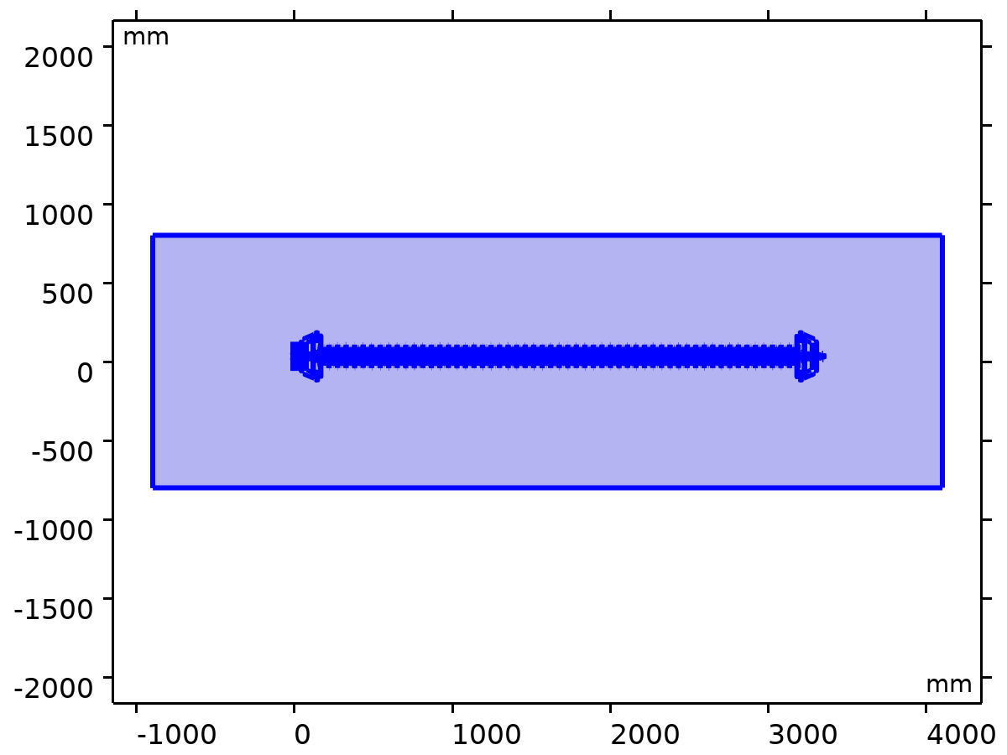
Electrostatics
Equations
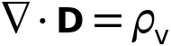

Features
Name | Level
Free Space 1 | Domain
Zero Charge 1 | Boundary
Initial Values 1 | Domain
Electric Potential 1 | Boundary
Ground 1 | Boundary

Mesh 1
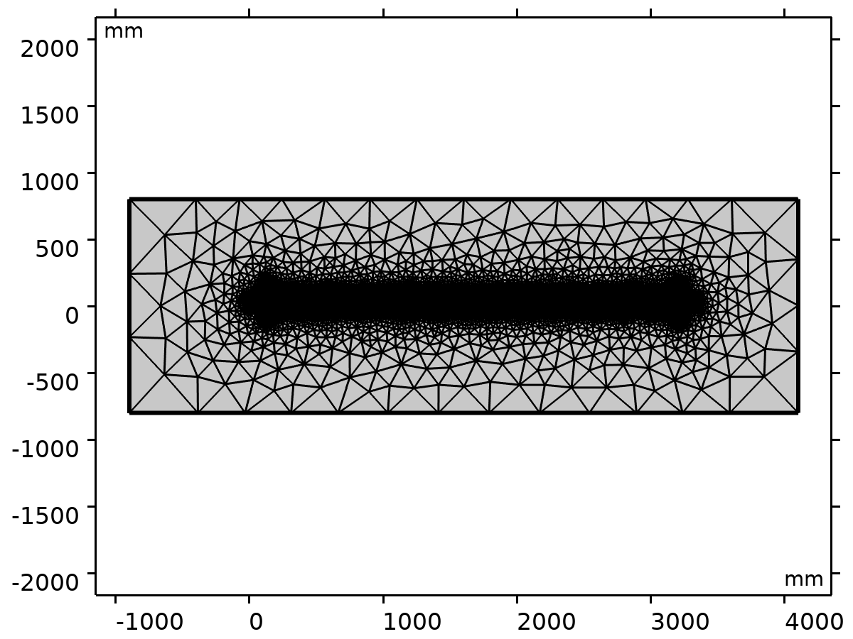
Mesh 1

Size (size)
Settings
Description | Value
Maximum element size | 650
Minimum element size | 30
Curvature factor | 0.6
Maximum element growth rate | 1.5
Predefined size | Coarser

Free Triangular 1 (ftri1)
Selection
Geometric entity level | Domain
Selection | Geometry geom1

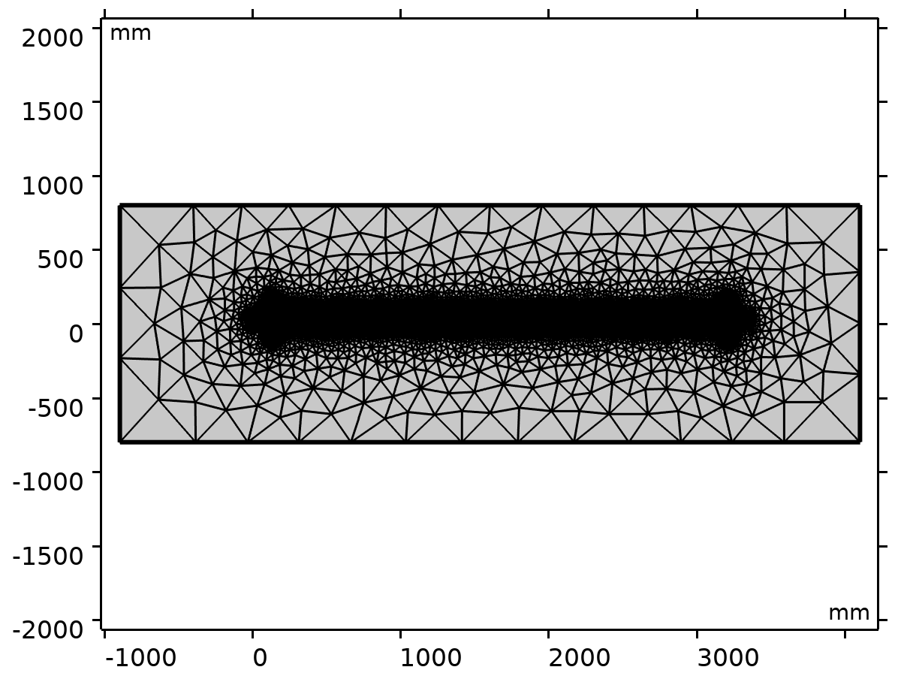
Free Triangular 1
Settings
Description | Value
Number of iterations | 4
Maximum element depth to process | 4

Information
Description | Value
Last build time | 12 seconds
Built with | COMSOL 6.3.0.290 (win64), Jul 5, 2026, 2:04:17 AM

Study 1
Computation information
Computation time | 4 s

Parametric Sweep
Parameter name | Parameter value list | Parameter unit
L0 | 220[mm] 240[mm] 260[mm] 280[mm] 300[mm] | mm

Study settings
Description | Value
Sweep type | Specified combinations
Parameter name | L0
Unit | mm

Parameters
Parameter name | Parameter value list | Parameter unit
L0 (total length of insulator) | 220[mm] 240[mm] 260[mm] 280[mm] 300[mm] | mm

Stationary
Study settings
Description | Value
Include geometric nonlinearity | Off

Physics and variables selection
Key | Solve for
Electrostatics (es) | On

Store in output
Interface | Output | Selection
Electrostatics (es) | Physics controlled

Mesh selection
Component | Mesh
Component 1 | Mesh 1

Results

Datasets

Study 1/Solution 1
Solution
Description | Value
Solution | Solution 1 (sol1)
Component | Component 1 (comp1)

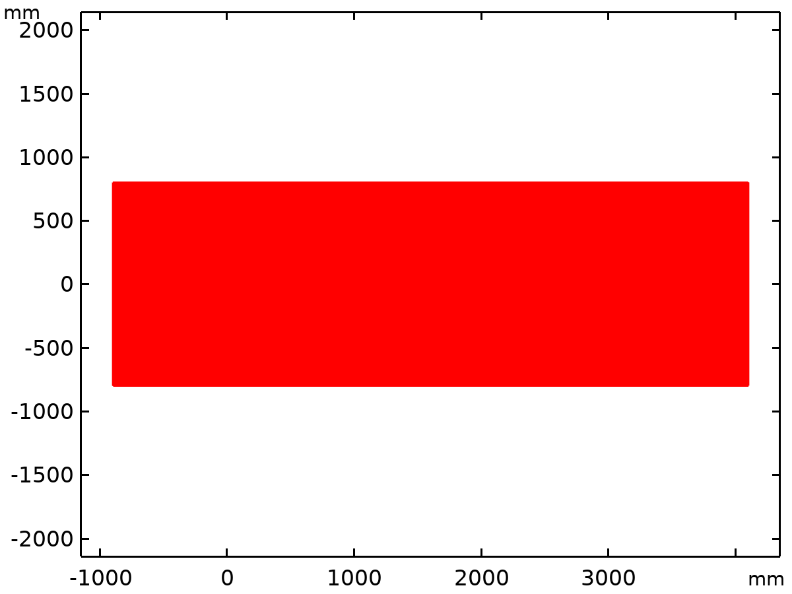
Dataset: Study 1/Solution 1

Cut Line 2D 1
Data
Description | Value
Dataset

Line data
Description | Value
Line entry method | Two points
Points | {{18, 0}, {80, 3350.7}}

Advanced
Description | Value
Space variable | cln1x
Normal variables | {cln1nx, cln1ny}
Tangent variables | {cln1tx, cln1ty}

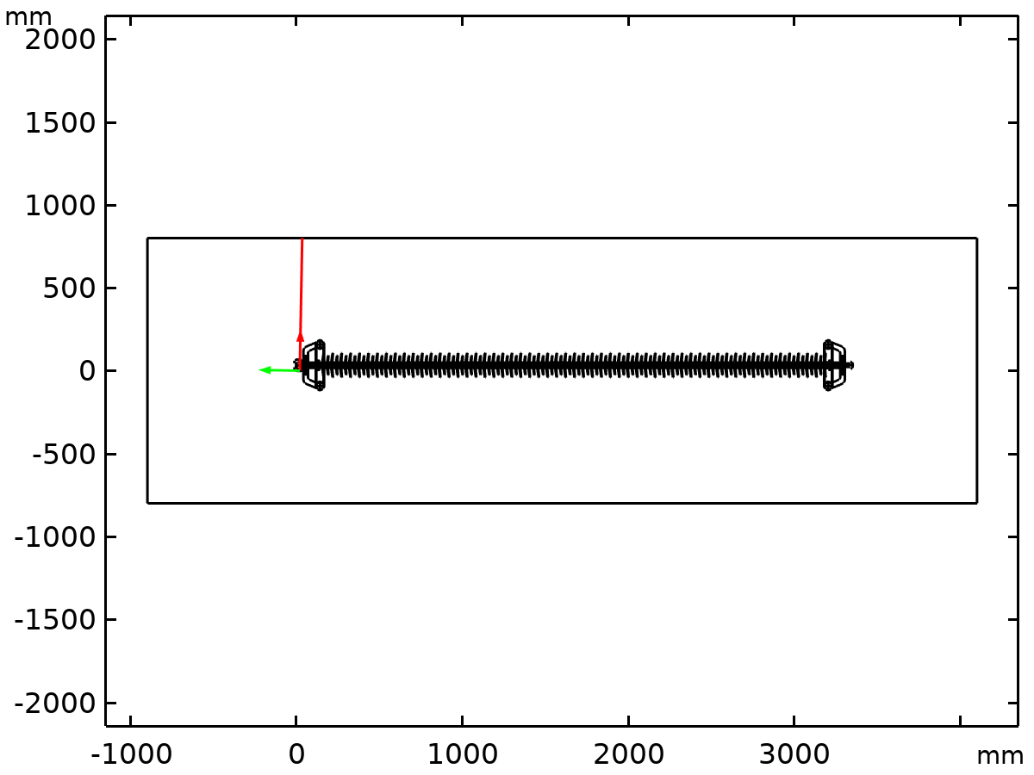
Dataset: Cut Line 2D 1

Edge 2D 1
Data
Description | Value
Dataset

Tables

Maximum and Minimum Values
Graph marker

Plot Groups

Electric Potential (es)
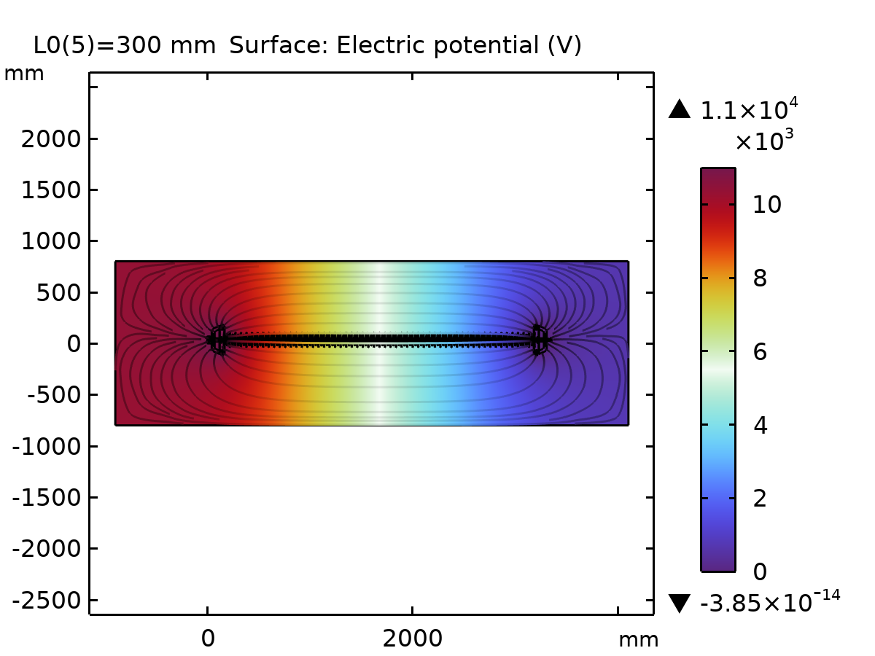
Surface: Electric potential (V)

Electric Field (es)
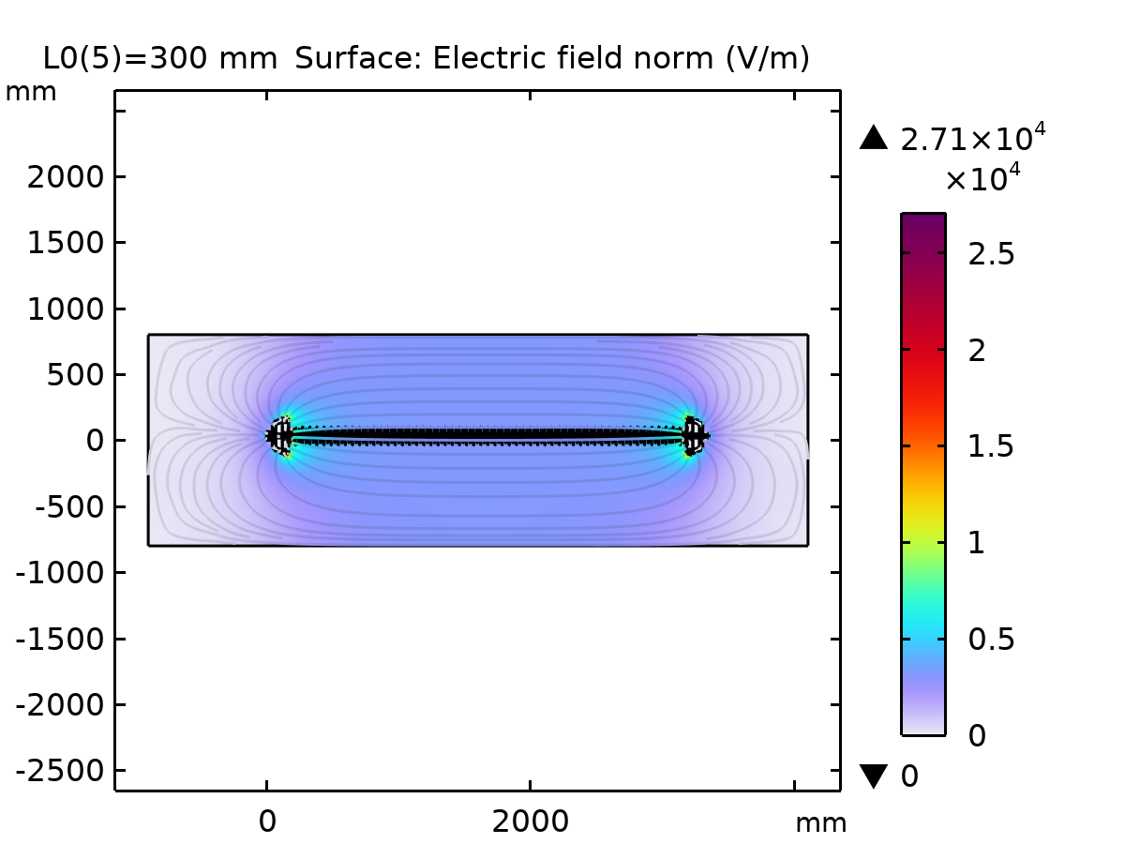
Surface: Electric field norm (V/m)

1D Plot Group 4
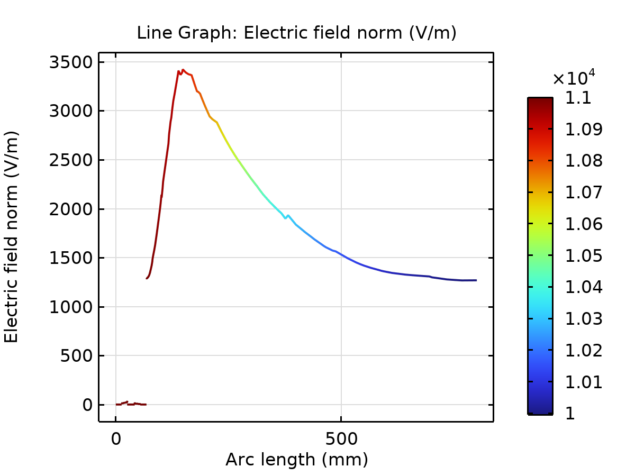
Line Graph: Electric field norm (V/m)

